**Naveen Bonala Task for Terraform-02.**

1. Execute all the templates shown in video.

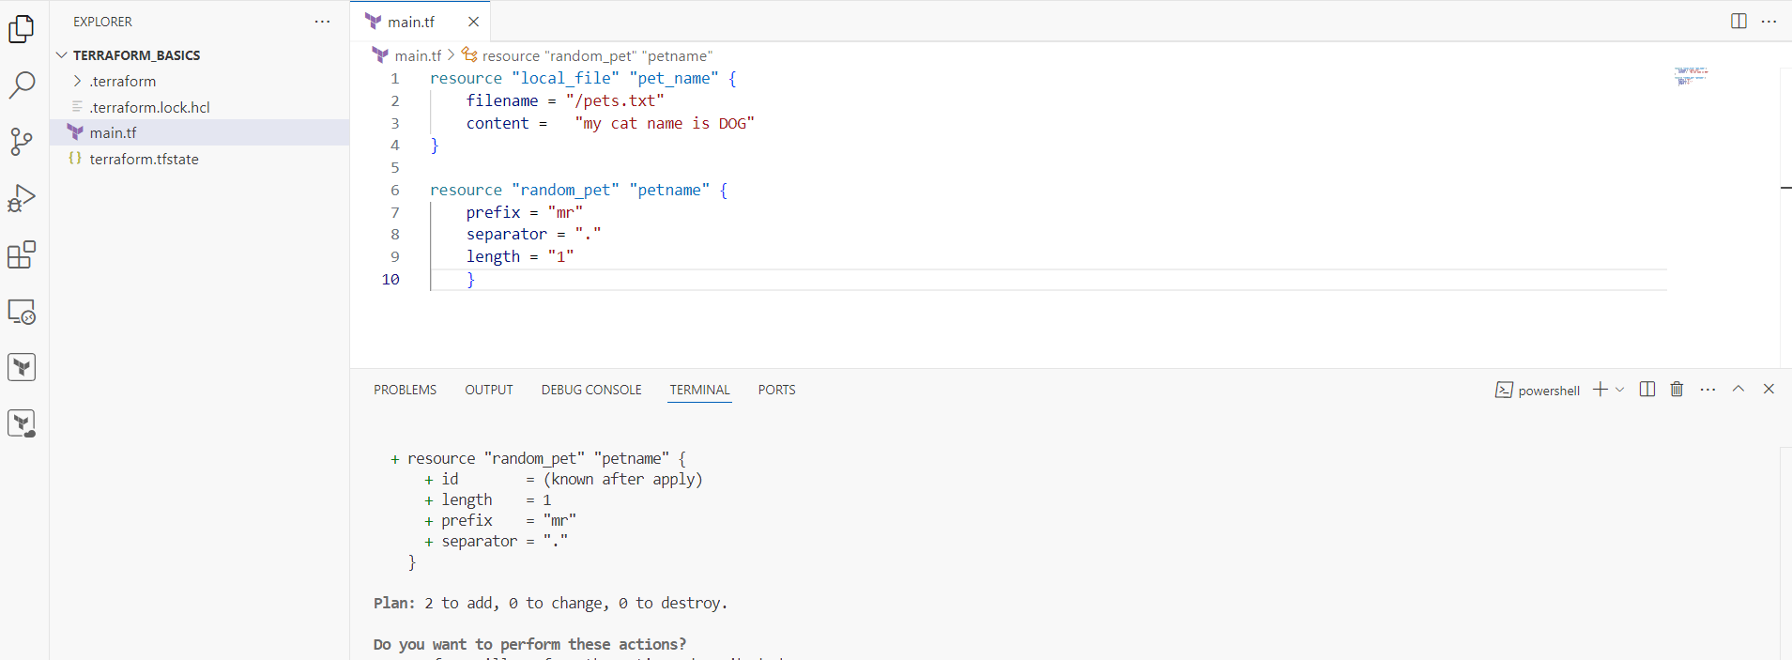

create_before_destroy

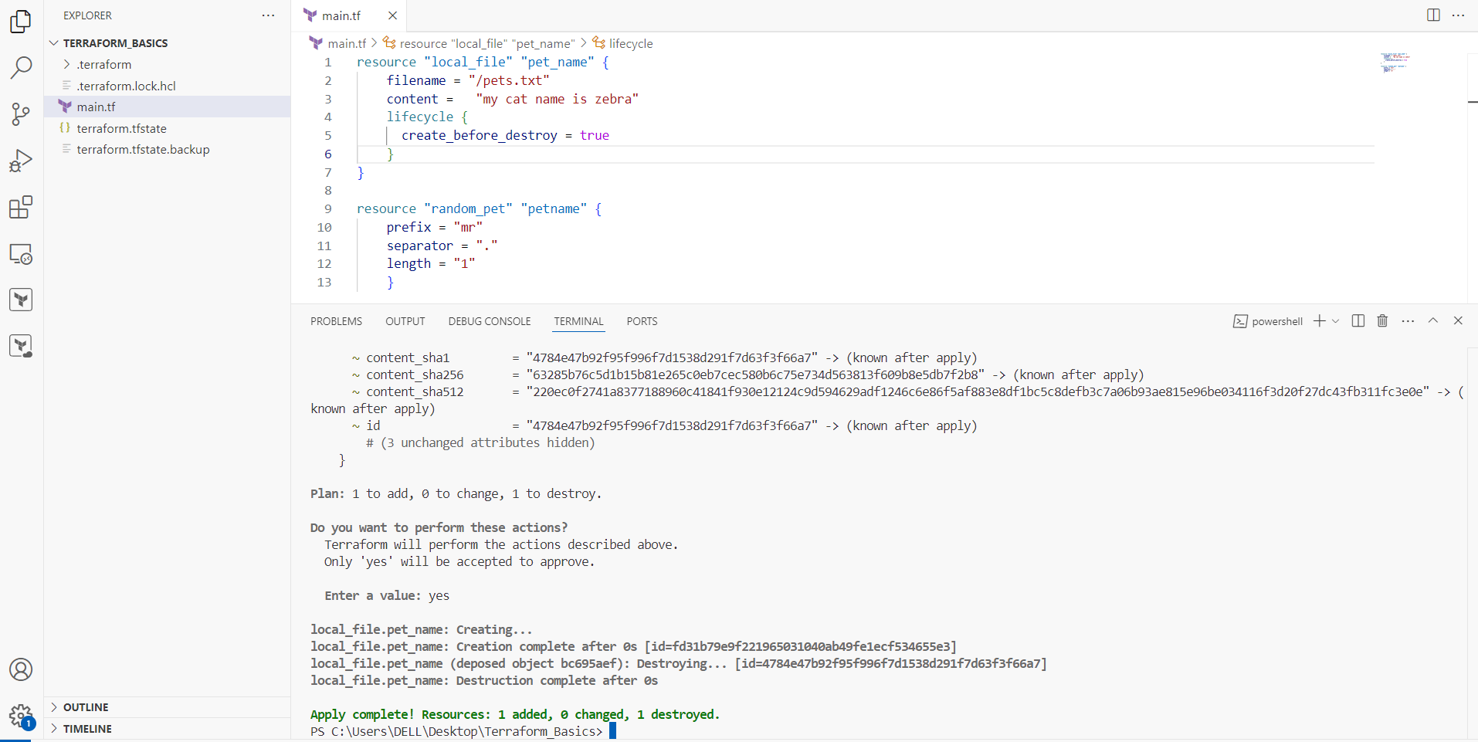

prevent_destroy

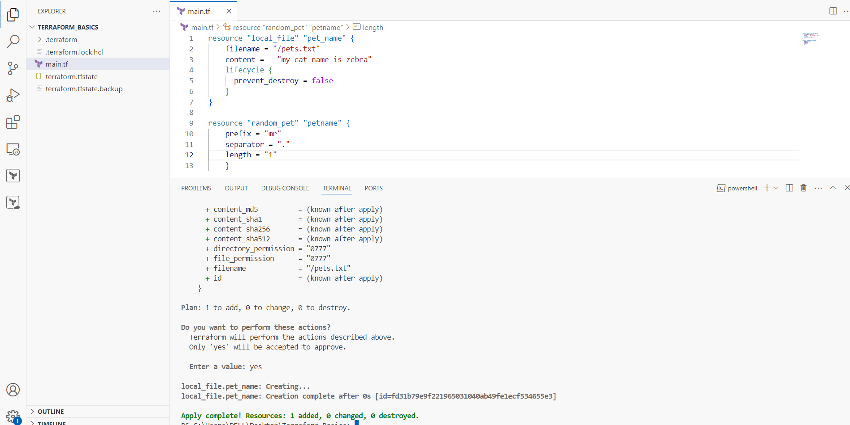

Ignore_changes

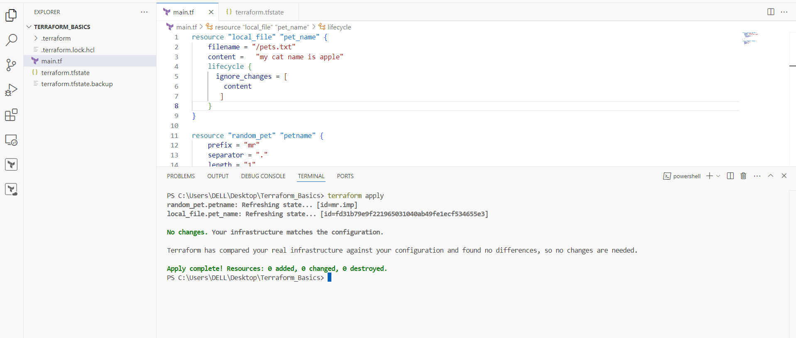

Variables

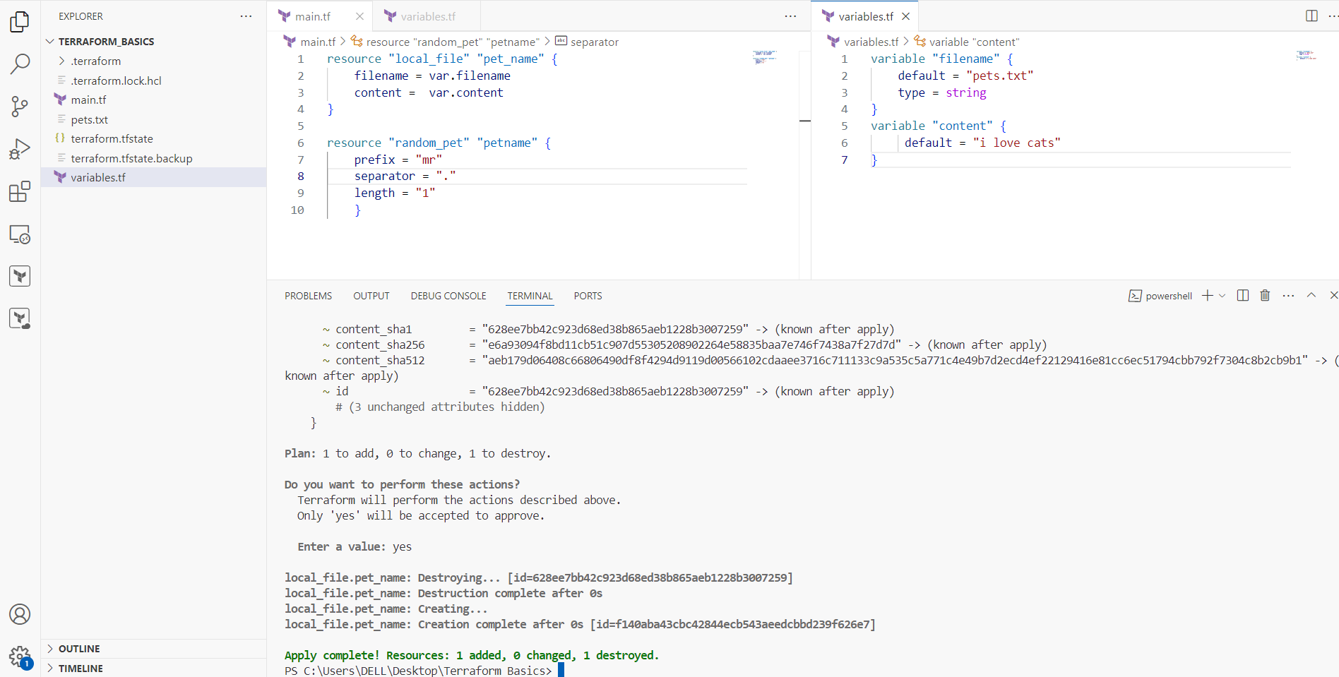

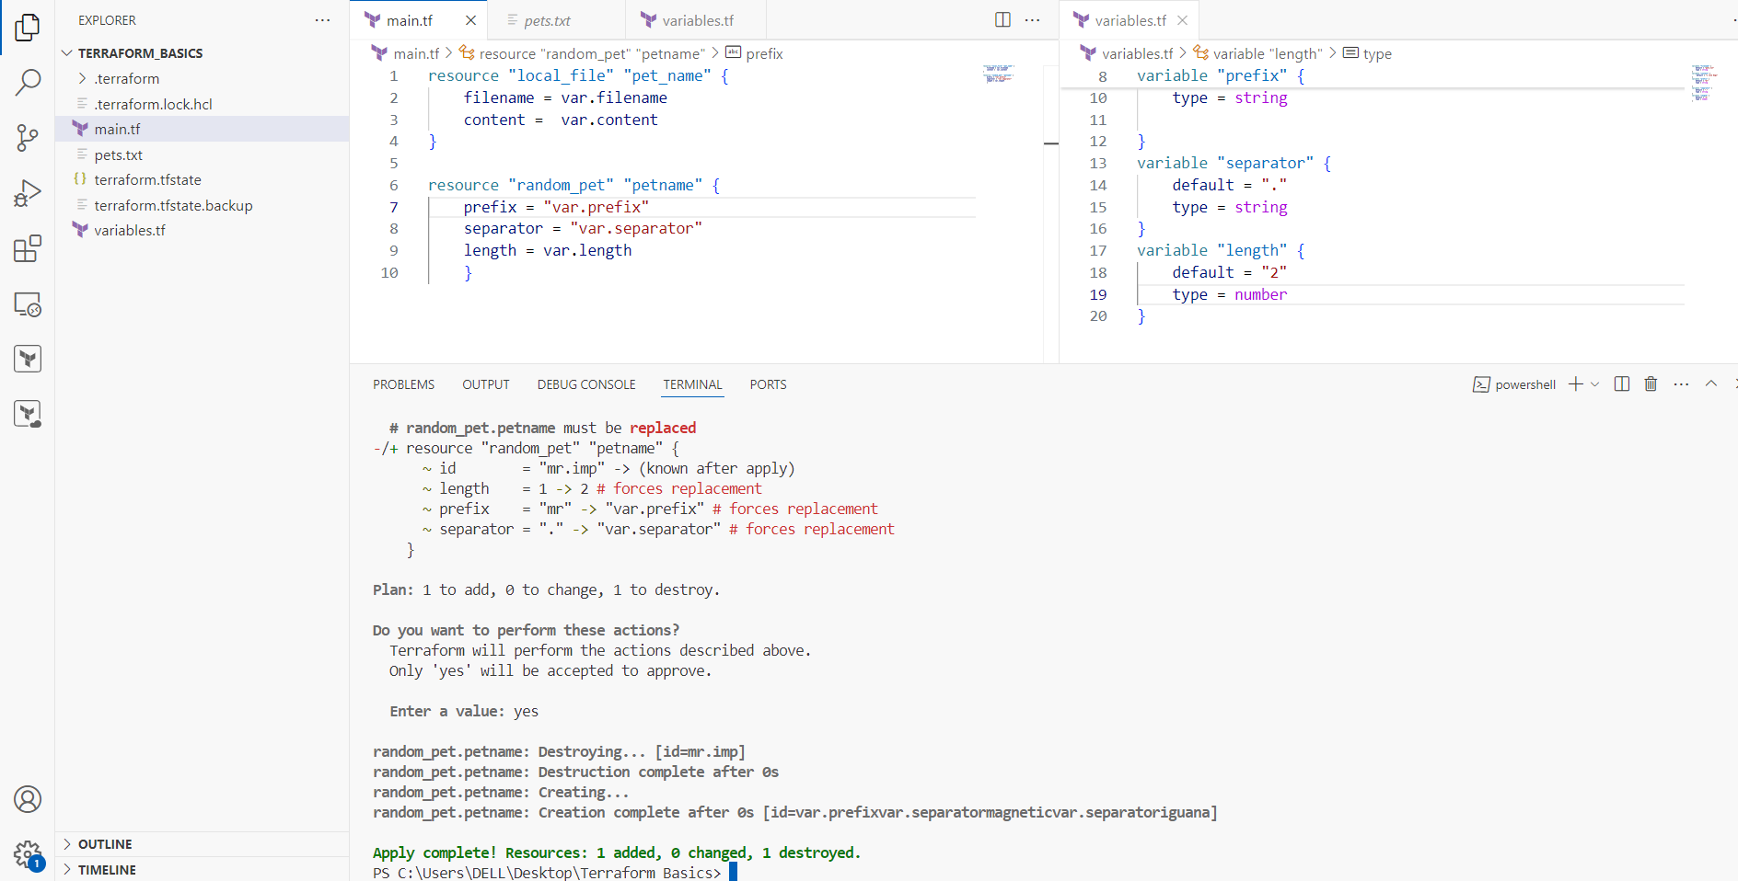

1. Integrate terraform in jenkins using Terraform plugin.